My first snow

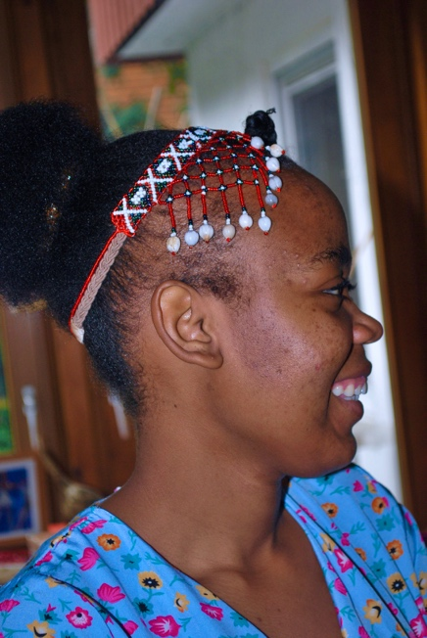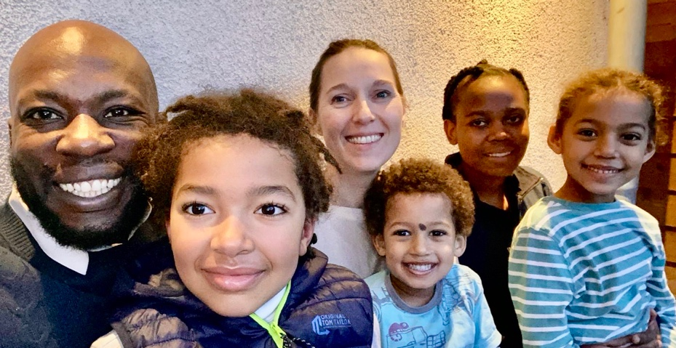

During my stay for the past six months with my host family in wintertime, l had the opportunity to experience a different side of the country and culture. Living with a German family allowed me to immerse myself in their daily lives, traditions, and customs, which was an enriching and eye-opening experience.
One of the highlights of my stay was spending time with the kids in the family. They were full of energy, curiosity, and joy, and their excitement for the winter season was contagious. We spent our afternoon building snowballs and snowmen, ice skating, which was so frozen, and sipping hot tea by the fireplace.

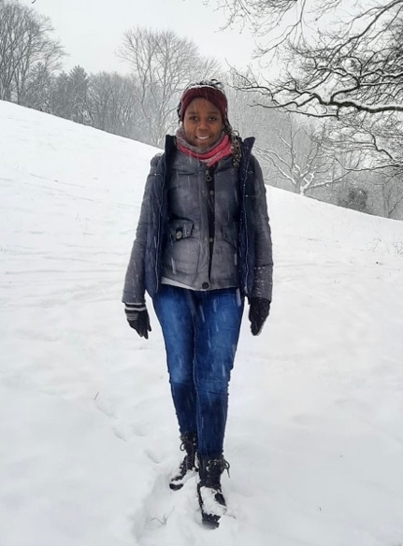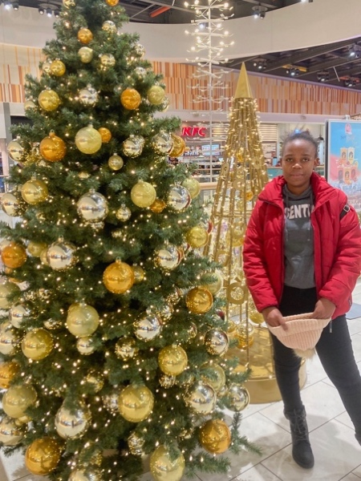
I had one of the best traditional German holiday treats. l tested a Christmas stollen, it is a traditional German Christmas bread. During the Christmas season, the cake like leaves is called Weihnachsstollen. We decorated the Christmas tree together, and it was heartwarming to see how family and togetherness were central to their celebration.
The season has always been a magical time for me and my friends. It is a time when we come together to celebrate the season, enjoy each other's company, and create lasting memories. One particular winter stands out in my memory, my first coursework in wintertime with my friends.
As we arrived at the winter course venue, the air was crisp with a hint of snowflakes in the air. We were all excited to embark on this adventure together, eager to explore the winter wonderland and participate in the various activities that were planned for the week.
These courses provide a valuable opportunity for individuals to come together, learn new skills, and build lasting friendships. The impact of my first course in wintertime with my friends was profound. Not only did it provide me with an opportunity to bond and create memories, but it also allowed us to push our limits and discover new passions.
From a positive perspective, my first course week in wintertime with my friends was a transformative experience that allowed me to create cherished memories. l will always treasure.

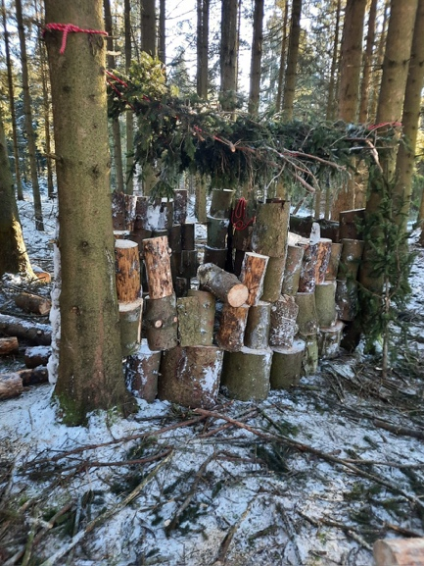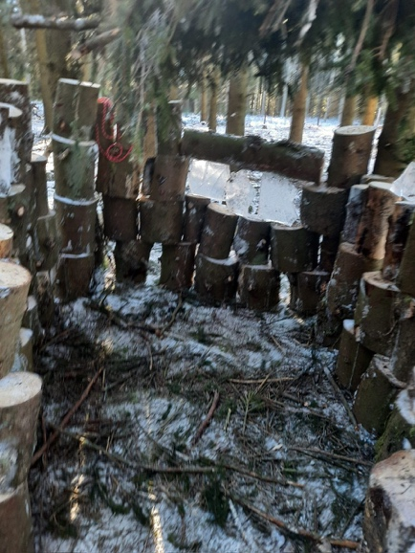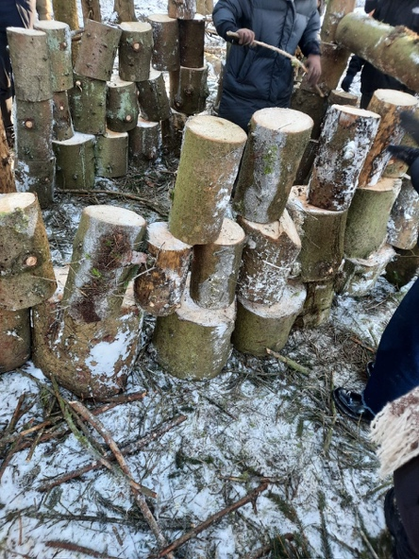
Apart from spending time with family and friends. l also had the opportunity to continue the work in a home for elderly people during my stay. Working in a home for the elderly people as volunteer it has offered me a unique opportunity to gain a hand on experience in health care, develop valuable skills, and make a positive different in the lives of others.
It brings joy, laughter, happiness, and tears at the same. Whenever I make my hair old people are always happy. They say, can l touch your hair, is this your natural hair? Can l touch your face? Well, trying to see my hair, they hold my hands and realized my hands are cold, they hold me so tight to keep me warm. It's so touching and heartwarming.
Despite its many positive aspects, working in a home for elderly people as a volunteer also presents challenges and obstacles. One of the key aspects l have encountered, is the emotional impact. Coping with loss and grief has been a significant challenge as l often form deep connections with the residents. It is essential to find a balance between empathy and emotion boundaries, as it can be overwhelming to constantly experience the emotions of others.
Nevertheless, my first snow in wintertime with friends and family was a truly memorable experience that had left a lasting impact on me. From the key figures to positive and negative aspects of the experience, l have gained a deeper understanding and appreciation for the value of cultural exchange. As l look back on those days with fondness, I am grateful for the opportunities it provided and the memories it created. l look forward to many more adventures and the sun.

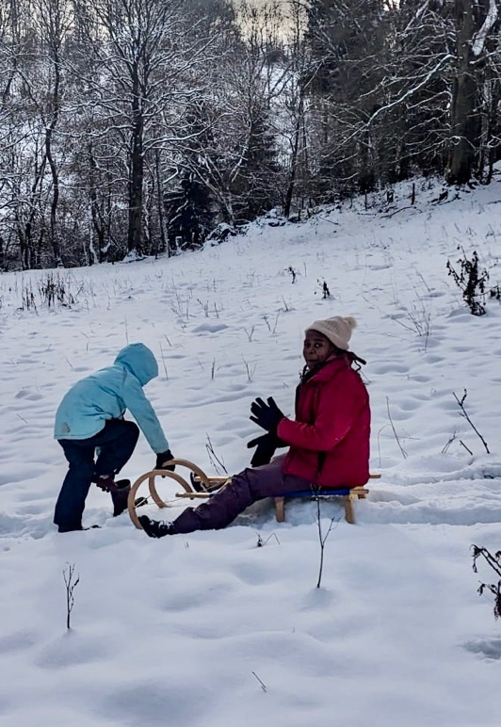

Rosemary Simujayabana

